**Challenge 2.**

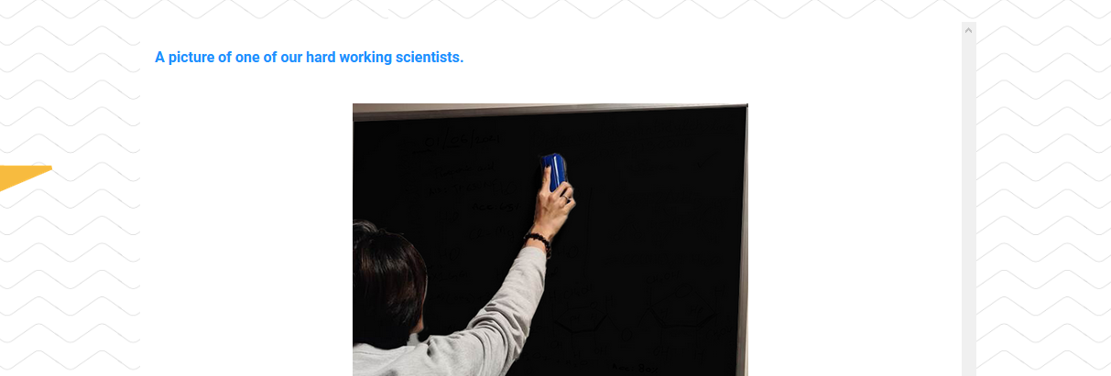

1. First step is to exam the file via exiftool. Nothing there.
2. It’s a pretty high res image and there seems to be something besides just black on this blackboard. Opening it in gimp.
3. A simple edge detection filter returns some interesting results:

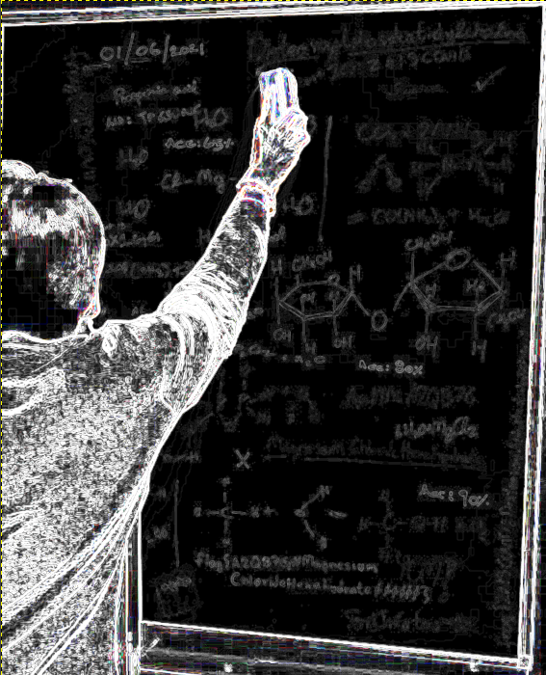

1. Even more interesting is something written at the bottom:

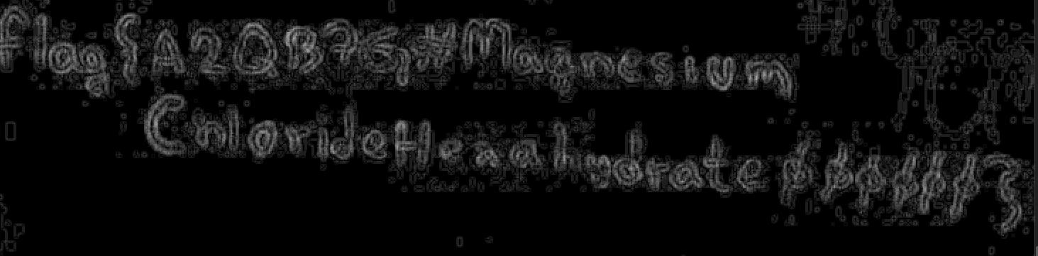

It takes a quick good of chemical compounds to figure out what exactly is written down because the letters are a bit blurry:

Flag{A2QB7G#MagnesiumChlorideHexahydrate000000}